USER REQUIREMENTS

The Bidder should provide the following in the specified order in Section 4 of the proposal/bid document.

Provide detail information of the proposed solution as per document enclosed. Please note that marking should be carried out in the following manner; The Remarks column should be used to explain or provide detail information.

DESCRIPTION | REMARKS
Rating - 5 | If the User requirement is met 100% as defined in the RFP without any work around method.
Rating - 4 | If the User requirement is met 75% as defined in the RFP without any work around method. Define the number of hours required for the modification and cost in US$ in the Remarks column, in order to provide 100% functionality as defined.
Rating - 3 | If the User requirement is met 50% as defined in the RFP without any work around method. Define the number of hours required for the modification and cost in US$ in the Remarks column, in order to provide 100% functionality as defined.
Rating - 2 | If the User requirement is met 25% as defined in the RFP without any work around method. Define the number of hours required for the modification and cost in US$ in the Remarks column, in order to provide 100% functionality as defined.
Rating - 1 | If the User requirement is met as a Work around method defined in the RFP. Define the number of hours required for the modification and cost in US$ in the Remarks column, in order to provide 100% functionality as defined.
Rating - 0 | If the User requirement is not met as a defined in the RFP and modifications are required. Define the number of hours required for the modification and costs in US$ in the Remarks column.

The NBL rating is as follows:
1 = critical; 2 = essential; 3 = nice to have

CONSUMER CREDIT OPS (CPU) – TERM LOAN FACILITIES
Ref | Requirements | NBL Priority | Bidder Rating | Bidder’s Remarks
 | GENERAL REQUIREMENTS
 | Should have the flexibility of setting up of multiple loan products/ schemes | 1 | 5 | T24 enables a bank to design different products, combining all kinds of loaning with each other, creating the difference of product. The development of a new product is very simple, through the tools and sub systems available in T24 which are integrated in product package designed for the bank.
 | Should be able to identify the business line / Account officer at facility account level | 1 | 5 | Account officer is a mandatory field that should be filled. Beside main account officer, T24 provide another account officer field for user to fill other account officer  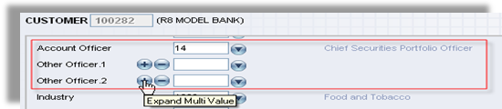  Figure 1. Account officer in customer level  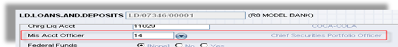  Figure 2. Account officer in loan level
 | In the event the facility being granted against a Deposit account the account pledged as collateral should be linked to the facility account and a lien created for the amount or percentage specified. | 1 |  | Deposit is supported as internal collateral in T24.  Allow automatic rating of collaterals using external news feeds, especially for collateral stocks and bonds.  Support management of collateral status (including closed, in-progress, and in-transit collateral).  Values are awarded to collaterals in various forms such as nominal, accepted, third party and specific values for general ledger and regulatory reporting. Such values may be either entered as collateral specifically or fed from another T24 module or even from external feeds via interfaces.
 | In the event the deposit under lien matures, the matured deposit should be renewed with lien and the new deposit details be updated to the loan contract. | 1 | 5 | Handled by T24 Collateral module.
 | Should be able to book more than one loan to a customer | 1 | 5 | Supported by T24
 | System should be able to accommodate LTV and verify loan amount against collateral |  | 4 | Verification will be by enquiry or report.
 | Should be able to share collateral with another facility, provided that the amount pledged does not exceed the total deposit value | 1 | 5 | Supported by T24
 | Should be able to link more that one deposit account / Collateral to a single facility. | 1 | 5 | Supported by T24
 | Such lien marked should be reflected in the deposit account | 1 | 5 | Marking will be by indication in a local reference field.
 | In the event of a Foreign Currency Deposit is pledged, Collateral valuation should be done by the system and any facility where there is in sufficient collateral be identified. | 1 | 5 | T24 has facility to have the online limit is fixed or variable. The underlying collateral should be recorded in the T24 Collateral Module.  The system recognizes two types of secured limit. A variable limit is one for which the system automatically allocates the value of any underlying collateral against the limit and calculates the ONLINE LIMIT amount on the basis of this secured amount. A fixed limit is similar, except that the value of the ONLINE LIMIT amount is never adjusted. In other words, the secured amount belonging to a fixed limit is calculated for information purposes but not for the system's limit checking.
 | Should be able to specify interest review dates. | 1 | 5 | Interest rate table is designed by effective date, any future interest rate can be defined  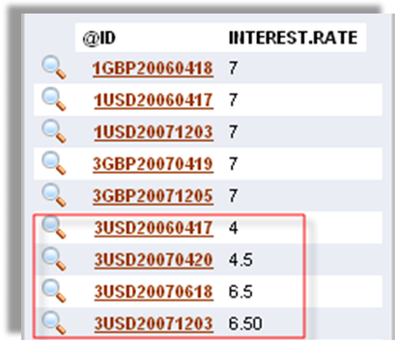  Figure 3. Interest rates are setup with effective date
 | Rate changes should be possible scheme wise and at account level | 1 | 5 | T24 has a comprehensive fee and charge structure for all payment services. Various types of fees (deposits, withdrawal, transfer, payment, etc) can be defined in the Charge or Commission Type table.  The fees and charges can be defined by product type, customer group or account type.  Overriding of the standard fees and charges is available at the customer level.  The fees and charges can be a flat amount or as one which varies according to the amount transferred. In this latter case different Percentages can be defined for different Bands or Levels of transferred amounts.
 | Should facilitate rate changes periodically. E.g. for a certain loan  scheme rates may need to be reviewed annually, for such loans the system should pick the current applicable rate of interest on the date the review is due and effect the rate change effectively | 2 | 5 | Handled by centralized interest tables in T24.
 | Feasibility to grant loans at zero interest. | 2 | 5 | Supported by T24.
 | Collect charges at the time of granting loans (charges deductible) |  | 5 | Supported by T24.
 | Multiple disbursement modes - Account Credit / Pay Order. |  | 5 | Disbursement mode can be set credit account, cash or check
 | Facilitate partial Disbursements. |  | 5 | Supported by T24
 | Have multiple repayment schedules i.e EMI, Equated Principle, Step up, Step Down, Bullet ect. |  | 5 | Handled by T24 Repayment designer.
 | Facility of having multiple re payment dates |  | 5 | T24 computes the debt (overdue) amount for every repayment that was due and not received by the bank. Once the payment is overdue no schedule can applied for the said payment unless the bank decides to settle the overdue payment completely and capture a new loan with the overdue payment as the Loan Principal and define a flexible schedule.
 | Should facilitate release of Excess Collateral. |  | 5 | Handled by the Collateral module using the reversal function.
 | System driven recovery on the respective due dates |  | 5 | Handled by T24 Past Due module.
- . | In the event the loan is in arrears, a hold / clock should be placed on the settlement account. As and when funds are deposited the overdue amount should be recovered and the hold/ block amount be adjusted accordingly |  | 5 | T24 can manage account blocking and unblocking. To do an account blocking, the locked amount together with the “from date” and “to date” will be input by the user. Unblocking before the to date is reached can be done subject to approval by a competent user with sufficient authority  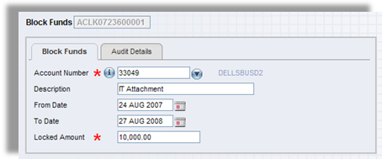  Figure 4. Block Funds
 | Provision to charge over due interest either by way of a percentage or an absolute amount. |  | 5 | Handled by T24 Provision functionality.
 | To create and add charges |  | 5 | Supported by T24.
 | Change loan settlement accounts and / or due dates after disbursement. |  | 5 | Supported by T24.
 | Should provide to effect partial pre payments and pre payments and also collect charges penalties either by way of a percentage or absolute amount. |  | 5 | Supported by T24.
 | Account level validations – i.e. Loan cannot be disbursed to a dormant / minors account | 1 | 5 | Supported by T24.
 | Ability to view limit / collateral history | 1 | 5 | Supported by T24.
 | Back valuation of Disbursement, and recoveries |  | 5 | Disbursement in T24 is one time disbursement, except for revolving loan type. For any requirement to have multi disbursement, than it can be separated in several loans. Revolving can be done in the limit setting
 | Write off’s |  | 5 | T24 allows waiver, financial write-off and write-off for all debt that is due. The action chosen will be decided by the bank on a case by case basis.
 | Waiving of Charges, Interest and capital |  | 5 | Supported by T24.
 | Provision to set off the Collateral for full settlement of loan |  | 5 | Manual set off supported.
 | NPA flagging and Provisioning as per CBSL guidelines | 1 | 4 or 5 | Handled by T24 Past Due module. Whether local enhancement is required will require examination of CBSL guidelines.
 | Liens to be automatically released when the loan account is closed. |  | 4 | Will require local enhancement. Currently lien is released manually.
 | Need a free text area to input remarks/comments in approval level | 1 | 5 | Narrative fields are provided normally in T24 applications.
 | Provision provided in the system for change of security to another (e.g. fixed Deposits, savings a/c, treasury bills, treasury bonds, Treasury bill repo, treasury Bonds and corporate paper) should be updated | 1 | 5 | If the bank’s database has disaster then backup files are restored to live server. Data will be restored up to last backup time in any case. In addition, with RMAN tool , the database can be replicated online to backup system so that the data ‘s been to backup careful if disaster happened
 | Deposit rates & Loan rate Combination | 1 | 5 | Handled by T24 centralized interest rate tables.
 | Reports / MIS Requirements | 1 | 5 | The TEMENOS Model Bank (T24) Management Information System (MIS) has been designed to provide financial management information on customers, products, departments, income and expense, average balances and other information, from which management may analyse profitability and performance.  T24 have various type of report to support all your requirements. However, the detail will be discussed further in contract negotiation. Some reports are available in T24, the other reports can be customized through the T24 development toolkit
 | Audit activity trail | 1 | 5 | Core Module – Security Management system.  Typically within a given transaction will be found all the information needed for audit purposes, quite apart from who has input and authorised the deal.  - The user who input the transaction and the date and time  - The user(s) who authorised the transaction  - The current status of the transaction  - Any warnings that the inputter and authorisers overrode such as tolerance (i.e. limits, rates, balances) violation.  - The reference numbers of the statement entries physically created.  - The reference numbers of any 'deliveries' made i.e. Telex, SWIFT, Advice type messages.  The facility also records non-transaction activity such as all applications entered and functions performed.  All security activities are also recorded as follows:  - Sign-on and sign off  - Failed sign-on attempts  - Password changes  - Password resets  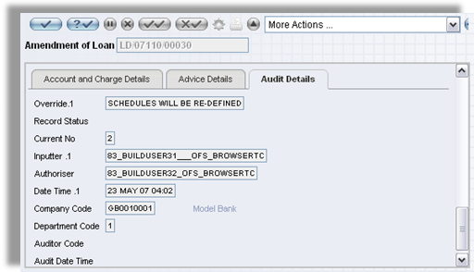  Figure 5. Amendment of Loan
 | Reviews falling due | 1 | 5 | All T24 applications and transactions can be retrieved easily by using enquiry designer, where the user can define what kind of information are needed to be printed in the reports or to be viewed
 | Collateral due for renewal | 1 | 5 | Supported by T24.  Support flexible restructuring of collateral portfolio and limit structure when customer dictates  The Collateral portfolio can be restructured at any time in T24
 | Overdue reviews | 1 | 4 | All T24 applications and transactions can be retrieved easily by using enquiry designer, where the user can define what kind of information are needed to be printed in the reports or to be viewed
 | Facility Disbursement advice to Customer | 2 | 5 | Supported by T24
 | Facility review letter / Advice to customer | 1 | 5 | Supported by T24
 | Balance Confirmation Advice – as at a specific date | 1 | 5 | Handled by T24 Delivery module.
 | Conformation of Interest/Capital paid for a given period | 1 | 5 | Supported by T24.
 | Collateral short fall report | 1 | 5 | Provided by similar standard reports and enquiries in T24.
 | Arrears Reminder |  | 5 | T24 has facility to print any advices and define the layout as needed in any loan activities. The print activity can be set automatic to be produced during the end of day.
 | Part payment advice |  | 5 | Supported by T24
 | Loan repayment schedule |  | 5 | Supported by T24
 | Limit history Report by Customer | 1 | 5 | Provided by similar standard reports and enquiries in T24.
 | Total given loans/Principal Balance/total Portfolio | 1 | 5 | Supported by T24
 | All the given facility details( loan a/ no, customer name, principal balance, amount disbursed, interest rate) | 1 | 5 | Supported by T24
 | NPL loans | 1 | 4 | All T24 applications and transactions can be retrieved easily by using enquiry designer, where the user can define what kind of information are needed to be printed in the reports or to be viewed
 | To Identify the facilities with special rate & fixed Tenor | 1 | 5 | Because of special rate is specific to each loan based on the agreement of account officer, in T24, Special rate is setup as interest spread in each Loan, which the based rate will follow the table and then system will add/subtract with interest spread.
 | Facilities lien over foreign currency deposits | 1 | 5 | Handled by T24 Collateral module.
 | What is the collaterals held for given OD | 1 | 5 | T24 Collateral module allows definition and handling of different types of collateral.
 | To identify the facilities with special rates & the tenor of the facility where special rates are approved | 1 | 5 | Supported by T24.

